|  |  |
| --- | --- |
| Ex.No:6 | **BOOK FRONT PAGE COVER DESIGN** |
| Date: |

AIM:

To design a book front cover page using HTML and CSS.

**ALGORITHM:**

STEP 1: Create a Django Admin project.

STEP 2: Create an app in the Django interface.

STEP 3: Create a folder named 'static' in the app folder.

STEP 4: Create a new HTML file in the static folder.

STEP 5: Write the HTML code with relevant CSS properties.

STEP 6: Choose the appropriate style and color scheme.

STEP 7: Insert the images in their appropriate places.

STEP 8: Publish the website in the LocalHost.

**PROGRAM:**

{% extends "BookFrontCover/base.html" %}

{% block title %}BOOK FRONT COVER App{% endblock %}

{% block content %}

    <style>

        body {background: #888; height: 100%;}

        span {color: #F57D11;}

        .book {

            display: block;

            position: absolute;

            height: 850px;

            width: 700px;

            overflow: hidden;

            top: 50%;

            left: 50%;

            -webkit-transform: translate(-50%,-50%);

            -ms-transform: translate(-50%,-50%);

            transform: translate(-50%,-50%);

            background: #393939;

        }

        .cover-design {

            display: block;

            position: absolute;

            height: 600px;

            width: 600px;

            top: 45%;

            left: 50%;

            -webkit-transform: translate(-50%,-50%);

            -ms-transform: translate(-50%,-50%);

            transform: translate(-50%,-50%);

            font-family: sans-serif;

            color: #EEE;

        }

        .diamond-frame {

            position: absolute;

            height: 325px;

            width: 325px;

            top: 64.8%;

            left: 14.5%;

            -webkit-transform: rotate(45deg) translate(-50%,-50%);

            -ms-transform: rotate(45deg) translate(-50%,-50%);

            transform: rotate(45deg) translate(-50%,-50%);

            border-left: 50px solid #AFA;

            border-right: 50px solid #CCC;

            border-top: 50px solid #FF7300;

            border-bottom: 50px solid #0BF;

        }

        .box {

            position: absolute;

            height: 50px;

            width: 52px;

            z-index: 1000;

        }

        .a {background: #840; top: -50px; left: -51px;}

        .b {background: #b40; top: -50px; right: -51px;}

        .c {background: #077; bottom: -50px; right: -51px;}

        .d {background: #0A9; bottom: -50px; left: -51px;}

        .book-title {

            position: absolute;

            width: 100%;

            font-size: 57px;

            top: 45%;

            text-align: center;

        }

        .book-subtitle {

            position: absolute;

            width: 100%;

            font-size: 24px;

            top: 55%;

            text-align: center;

        }

        .book-author {

            display: block;

            position: absolute;

            width: 100%;

            top: 90%;

            text-transform: uppercase;

            color: #777;

            font-size: 22px;

            font-family: sans-serif;

            letter-spacing: 2px;

            text-align: center;

        }

    </style>

    <div class="book">

        <div class="cover-design">

            <div class="diamond-frame">

                <div class="box a"></div>

                <div class="box b"></div>

                <div class="box c"></div>

                <div class="box d"></div>

            </div>

            <div class="book-Title"> HTML<span>&</span>CSS

        </div>

            <p class="book-subtitle">design and build websites</p>

        </div>

        <div class="book-author">Jon Duckett</div>

    </div>

{% endblock %}

OUTPUT:

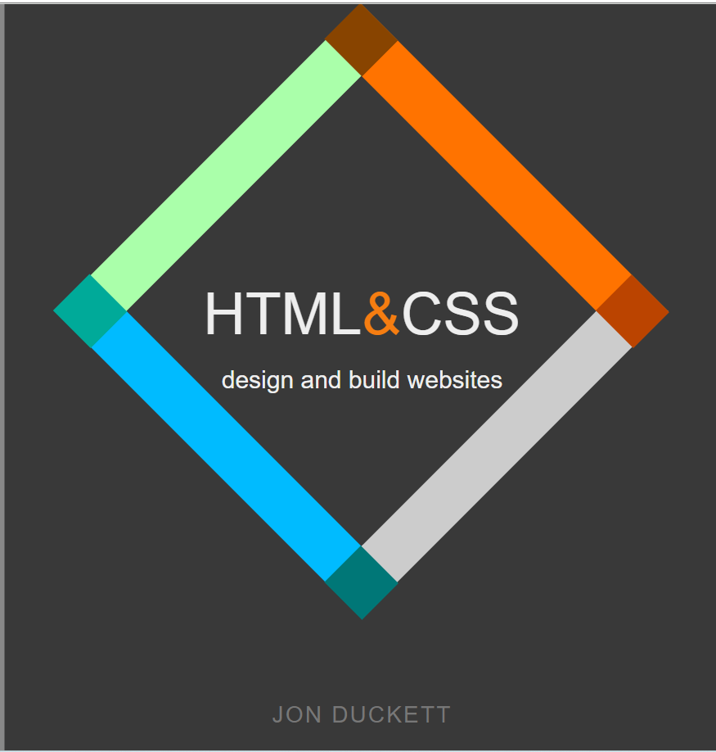

RESULT:

The program for designing book front cover page using HTML and CSS is

completed successfully.